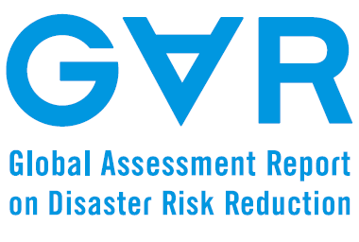
Januari 2014
WHEN TO CANCEL A TSUNAMI WARNING? A COMPREHENSIVE REVIEW FROM THE RECENT TSUNAMIS IN INDIAN AND PACIFIC OCEAN

Input Paper

Prepared for the Global Assessment Report on Disaster Risk Reduction 2015

Abdul MUHARI and Fumihiko IMAMURA
International Research Institute of Disaster Science
TOHOKU University, Japan

Table of Contents

SUMMARY 3
1. Introduction 4
2. Data and analyses 5
2.1 The case of 2010 Mentawai tsunami in Indonesia 5
2.2 The case of the 2011 East Japan tsunami 9
2.2.1 Near-field case in Japan 9
2.2.2 Far-field case in Papua, Indonesia 11
3. Conclusions and ways ahead 14
References 15

Figures
Figure 1. World biggest natural disaster in term of economic damage 4
Figure 2. World biggest natural disaster in term of casualties 5
Figure 3. The observed tsunami data from tide gauges in Padang and Tanah Bala during the 2010 Mentawai tsunami 6
Figure 4. The time line of the warning issued by the NTWC and Pacific Tsunami Warning Center (PTWC) during the 2010 Mentawai tsunami 7
Figure 5. Time series of the tsunami in the west coast of Pagai Island (part of Mentawai Islands) calculated from numerical model. Dash red line indicated time of the warning termination 8
Figure 6. The complete sequence of tsunami early warning (in local time; UTC+9) issued by the JMA during the 2011 East Japan tsunami 10
Figure 7. The observed tsunami data from RTK-GPS located in off the Tohoku coast during the 2011 East Japan earthquake-tsunami 10
Figure 8. The observed tsunami data from tide gauges located in Hokkaido during the 2011 East Japan earthquake-tsunami 11
Figure 9. The observed tsunami data from ride gauges located in southern Japan during the 2011 East Japan earthquake-tsunami 11
Figure 10. The observed tsunami data from tide gauges located in Papua region, Indonesia (Khafid and Handayani, 2011) 12
Figure 11. The snapshot of the tsunami wave height and currents in the Papua Bay. Big arrow pointed location of the tsunami victim 13

SUMMARY
An early warning for a specific hazard is ideally issued before it impacts the community and should be terminated after the hazards are no longer threatening safety. Practically, however, uncertainties and different circumstances can yield underestimation (or sometimes overestimation) of the hazard magnitude, bringing a potentially false decision especially regarding the warning termination time. This article focuses on elaborating on the problems underlying the false termination time in case of tsunami early warning in developing countries. Two tsunami events are analyzed namely the 2010 Mentawai tsunami in Sumatra, Indonesia and the impact of the 2011 East Japan tsunami in Papua region, Indonesia. Both events caused loss of life, thus improvements are needed to reduce such impacts in the future. By using the observed tsunami data from tide gauges and post-tsunami surveys, we found that a lack of dissemination and communication facilities, human capacity at the local level and insufficient amount of real time monitoring equipment are the major problems of the unnecessary warning cancellation for both events. Utilization of a local scale numerical model is proposed as the most feasible solution to the problems above. However, one issue remains, that is the availability of the detailed topographic data to support the modeling efforts.

1. Introduction
There are four components that should be performed in an integrated manner so that the concept of people centered early warning can be run effectively (Basher, 2006). First is risk knowledge that updates the dynamics of spatial and temporal variability of hazards and vulnerability. Secondly, monitoring and warning service that provides the scientific basis for predicting and forecasting, and which ensures the warning issuance in a timely fashion. Third, dissemination and communication that guarantee people even in the remote areas receive warning, and allow them to immediately react according to the contingency and emergency response plan. The latter can only be performed by sustainable and systematic education and preparedness programs, which will increase the response capability as the last part of the four components.
Since the Boxing Day tsunami in 2004, major disasters have continued to occur with significant economic damage and remarkable loss of life. Figure 1 shows the biggest natural disasters worldwide in term of economic damage, and demonstrates that natural disasters which occurred in developed countries potentially brought significant economic impacts. Meanwhile, if a natural disaster occurred in developing countries, the loss of life is the major challenge rather than economic its economic impact as it is shown in Fig. 2.
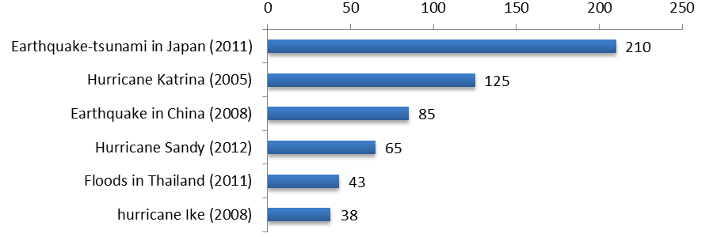
Figure 1. World biggest natural disaster in term of economic damage
The objective of the people centered early warning is to empower the people and communities to react in sufficient time and appropriate manner in order to reduce the possibility of personal injury or loss of life. Thus, Figs. 1 and 2 suggest that the objective to improve the early warning should be focused on developing countries that potentially have a greater human vulnerability in comparison to the developed ones.
This paper specifically aims ed to emerge to highlight a ‘hidden problem’ which was missing a detailed discussion during the development of the multi-hazard early warning concept. In the scheme of people centered early warning, we concentrate on the third component and tempted to show that aside of the rapid issuance and appropriate warning message, the criteria to cancel a warning plays a very important role in ensuring the safety of the community-at-risk. We took into account two events in Indonesia during the 2010 Mentawai tsunami in Southern Sumatra and the 2011 Japan tsunami in Papua Indonesia as case studies. The tsunami warning in these two events was terminated as the tsunami was still ongoing, thus caused loss of life. We analyzed the observed tsunami data and warning sequences from both events to reveal the underlying problems and suggest practical solutions that are feasible for developing countries.
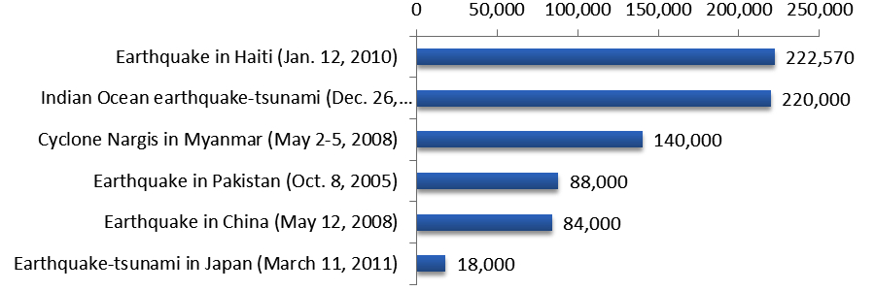
Figure 2. World biggest natural disaster in term of casualties

2. Data and analyses
Observation data from 23 tide gauges and 5 Real Time Kinematik (RTK) GPS buoys are used (MLIT, 2011). In addition, tsunami modeling efforts are also conducted by expanding previous research for both events using a world standard tsunami model (IOC-UNESCO, 1997). The 2010 Mentawai tsunami is analyzed from tide gauges in Indonesia, while the 2011 East Japan earthquake-tsunami is studied from tide gauges and GPS buoys in Japan for the near-field analysis and tide gauges in Indonesia for the far-field analysis respectively.
In Indonesia, an end-to-end tsunami early warning system (INA-TEWS) was developed after the 2004 Indian Ocean tsunami. This system consists of two major components; the first is the structural part, which comprises the equipment such as seismic observation network, tsunami observation facilities, and GPS. The second is the cultural part, which is defined as the dissemination and response at the community level (Pariatmono, 2012). Components in the first part are integrated in a Decision Support System (DSS, Steinmetz et al. 2010) available at the National Tsunami Warning Center (NTWC) in Jakarta. Even though the system has been launched since November 2008, a detailed assessment of the two events described in the next sections below shows that an urgent improvement is needed, not only in dissemination and outreach, but also on the warning cancellation criteria.

2.1 The case of 2010 Mentawai tsunami in Indonesia
A ‘slow’ earthquake with magnitude 7.7 M_{W} occurred in shallow regions of the Sunda Trench off the Mentawai coast on October 25, 2010. The shaking intensity was not so strong and thus prevented people to take precautionary action in response the ground shaking. The type of earthquake in 2010 is contradictory to the one which occurred three years before, where strong tremors followed the M 8.4 earthquake in September 2007 nearly in the same region. The 2007 earthquake was followed by a very weak tsunami affecting villages in Mentawai Island, which becomes the heuristic in the islander’s mind in responding the earthquake; ‘strong earthquake occurred very close to the islands brought only minor tsunami’. So, one can assume that only small ground shaking might not come with with any destructive waves (e.g. Hill et al. 2012). However, the 2010 earthquake which occurred in the shallow sediment near the trench had a larger slip which increased the peak of the initial tsunami wave (Satake et al. 2013; Lay et al. 2011). The modeling results (Muhari et al. 2010) show that the tsunami attacked Mentawai Islands in less than 15 minutes and oscillating significantly in small bays along the islands up to two hours, which amplified tsunami heights up to eight meters. This finding was confirmed by post-tsunami surveys, which recorded tsunami heights up to nine meters (Satake et al. 2013; Hill et al. 2012).
The National Tsunami Warning Center (NTWC) in the Indonesian Meteorological Agency (BMKG) was able to issue the warning within five minutes after the earthquake. Procedurally, the warning is updated and eventually terminated based on confirmation from the local authority and/or based on the real time observation data of tsunami waveforms from the available tide gauges. During the 2010 Mentawai tsunami, however, the failures on warning dissemination and communication firstly occurred because the warning was not able to reach people in the very rural areas of Mentawai Islands (Satake et al. 2013; Pariatmono, 2012; Mikami et al. 2013). Secondly, the warning lasted only up to 47 minutes since there was no confirmation obtained from the local authority. It is true that the first factor may be more influential than the second in determining the number of casualties, but inappropriate warning cancellation can also imperil those who were told the tsunami hazard had been diminished. At that time –possibly up to present, there exists a lack of critical facilities to disseminate the warning to the very rural areas, thus confirmation of the tsunami occurrence and its impact is difficult. In addition, there were no tsunami observation facilities available in the vicinity of Mentawai Island. Closest tide gauges are located in Seblat, Padang and Tanah Bala (Fig. 3), at a distance of around 250 to 350 km from the epicenter. The energy radiation of the tsunami therefore is not significantly observed since the maximum tsunami height reaches only up to 0.4 m.
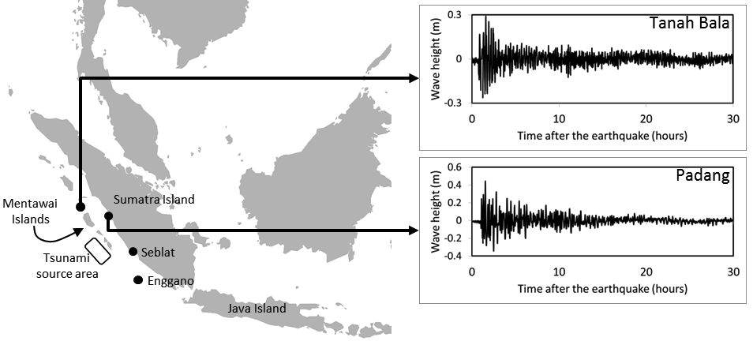
Figure 3. The observed tsunami data from tide gauges in Padang and Tanah Bala during the 2010 Mentawai tsunami
The warning sequence issued by the NTWC during the 2010 Mentawai tsunami is given in Fig. 4. By referring to the timeline, one can assume that that NTWC recognizes the occurrence of the tsunami; but weak tsunami as observed at the tide gauges far way cannot represent the actual condition in the islands near the source. As the result, the warning was cancelled due to underestimated tsunami hazard in addition to the absence of confirmation from the local authority.
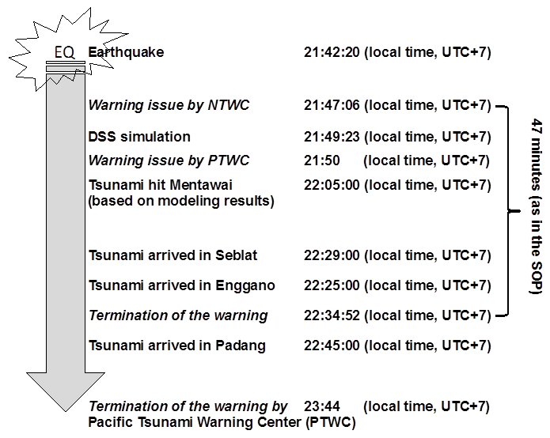
Figure 4. The time line of the warning issued by the NTWC and Pacific Tsunami Warning Center (PTWC) during the 2010 Mentawai tsunami
From a regulatory point of view, this decision is not completely wrong; the decision is in accordance with the NTWC internal Standard Operation Procedures (SOP) that warning will be terminated in a specific time span if there is no confirmation of the tsunami occurrence from the local authority. However, one can also question the decision by NTWC by comparing the timeline between the NTWC and the PTWC (operated by the National Oceanic and Atmospheric Administration, NOAA-US) who canceled the warning one hour longer than the NTWC.
In a similar condition where no significant tsunami was observed, the PTWC requested two hours tsunami watch before the warning eventually terminated. However, the aim of this article is not the comparison between the warnings issued by those different institutions. We attempt to discuss the underlying matter so ideas for improvement can be proposed. In the context of who will be responsible to declare and to clear the warning, both institutions have similar opinions as expressed in the last update/warning termination by the PTWC as follow,
‘A SIGNIFICANT TSUNAMI WAS GENERATED BY THIS EARTHQUAKE. HOWEVER...SEA LEVEL READINGS NOW INDICATE THAT THE THREAT HAS DIMINISHED OR IS OVER FOR MOST AREAS. THEREFORE THE TSUNAMI WATCH ISSUED BY THIS CENTER IS NOW CANCELLED.

FOR ANY AFFECTED AREAS - WHEN NO MAJOR WAVES HAVE OCCURRED FOR AT LEAST TWO HOURS AFTER THE ESTIMATED ARRIVAL TIME OR DAMAGING WAVES HAVE NOT OCCURRED FOR AT LEAST TWO HOURS THEN LOCAL AUTHORITIES CAN ASSUME THE THREAT IS PASSED. DANGER TO BOATS AND COASTAL STRUCTURES CAN CONTINUE FOR SEVERAL HOURS DUE TO RAPID CURRENTS. AS LOCAL CONDITIONS CAN CAUSE A WIDE VARIATION IN TSUNAMI WAVE ACTION THE ALL CLEAR DETERMINATION MUST BE MADE BY LOCAL AUTHORITIES.’

Here, the root problem pursed as the last statement in the PTWC message. Local authorities play an indispensable role in the warning dissemination and communication scheme. However, there may be inadequate human resources at the local level to take that indispensable task. To date, local actors still have limited understanding in the tsunami early warning in particular and disaster risk reduction in general. Spahn et al. (2010) indicated that the development of public and institutional response capability at the local level requires clear institutional arrangements and capacities. Fulfilling this gap may require sustainable efforts in medium- to long-term disaster education and capacity building activities.
In order to temporarily fill the gap and support the decision on warning cancellation, we exercise the use of numerical models to rapidly forecast the local tsunami. Actually, the decision support system in NTWC has already been equipped with the tsunami-modeling database derived from a huge number of earthquake scenarios (Strunz et al. 2011). However, the broad scale modeling resolution cannot resolve the tsunami evolution when it oscillates due to complex beach morphology at a local scale.
We extend the results obtained in Muhari et al. (2010) to the area along the west coast of Mentawai Islands (Fig. 5). We used a standard personal computer to run the model with a 90 m cell size topographic data for the smallest region around the islands. We found that it takes only around 45 minutes to complete the simulation for two hours calculation time. It means, if one uses the earthquake parameters determined by seismograph network owned by the NTWC, it will take only around 50 to 60 minutes to complete the simulation. If one uses more advance computational facilities or more advanced real time modeling for tsunami forecast (e.g. Gusman et al. 2013), less time is needed to complete the simulation to obtain a better prediction of tsunami hazard.
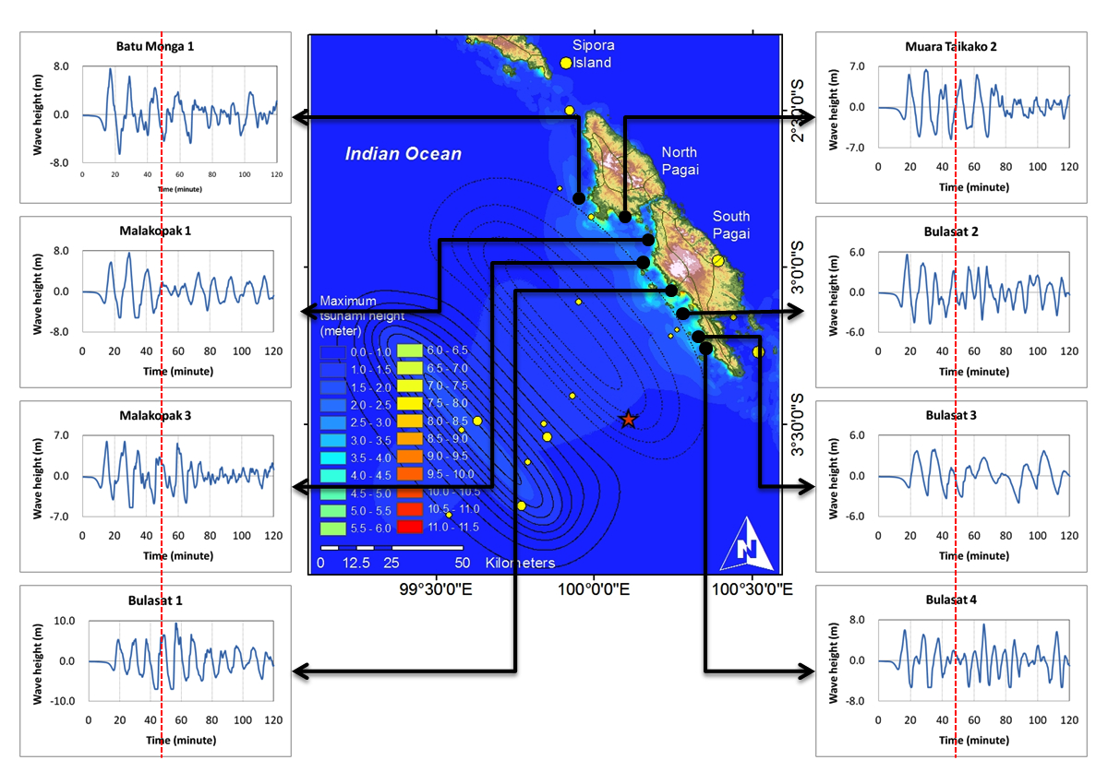
Figure 5. Time series of the tsunami in the west coast of Pagai Island (part of Mentawai Islands) calculated from numerical model. Dash red line indicated time of the warning termination
In the case of the 2010 Mentawai tsunami, numerical calculation indicates that significant waves continue to oscillate along the coast for more than two hours, which is in line with the observed data in Padang and Tanah Bala. These results are also consistent with a vivid account from Captain Lee Clark whose boat was swept away and anchored at a surf resort in Mentawai Islands due to the tsunami. He said that things settled down a few hours later after the earthquake, at approximately 01:00 AM (local time) on the 26th of October 2010 (Borrero et al. 2010). It means the tsunami energy takes about three hours to decay from its generation at 21:42 (local time) on the October 25, 2010.
The simple exercise by using the numerical calculation as shown above demonstrates that tsunami modeling at local scale can be very useful to estimate the tsunami hazard at a local scale. This could be very useful in supporting decision to cancel a warning if there is a lack of real time monitoring equipment as well as communication during the tsunami event.

2.2 The case of the 2011 East Japan tsunami
In Japan, the issue of the warning cancellation has been a concern since the early 2000s after some observations of abnormal tsunami height several hours after the leading tsunami wave arrived at the coast. However, most of the cases are the far-field tsunami that attacks Japan after travelling across the ocean and underwent scattering effect when it propagates through the ocean ridges (Koshimura et al. 2001; Mojfield et al. 2001; Koshimura et al. 2008). A method to detect the decay of tsunami wave has therefore been proposed (e.g. Hayashi et al. 2012) to avoid unnecessary warning cancellation when a tsunami is still ongoing.
The 2011 Japan tsunami gives an important insight on the warning cancellation criteria. In the near-field, the tsunami warning in this event may be the longest tsunami warning that has ever issued (Diposaptono et al. 2013). It lasted up to 42 hours (Hayashi, 2011). Even though the system failed to estimate the actual tsunami on its first and second dissemination, the system performed well in avoiding an underestimated decay of tsunami energy in coastal areas. The explanation below describes the tsunami observations during the 2011 tsunami event.

2.2.1 Near-field case in Japan
The development of tsunami early warnings in Japan underwent several steps and comprises several big tsunami events. Starting with a systematic forecast/warning system in 1941, the system is now becoming one of the most advanced tsunami early warning in the world (Imamura and Abe, 2009). Put aside the discussion about the limitations of the system particularly during the first warning phase of the 2011 East Japan tsunami case, here we focus on the description of its performance on the cancellation, which can be used as one of the best lesson learnt ever.
The complete sequence of tsunami warning during the 2011 East Japan tsunami issued by the Japan Meteorological Agency (JMA) is given in Fig. 6 (Hayashi, 2011). Even though the tide gauges along the Tohoku coast were mostly destroyed by the tsunami, one of the most important information comes from RTK-GPS buoys (Kato et al. 2000) installed around 50 km offshore (Fig. 7). In addition, some others tide gauges located in Hokkaido and in the southern part of Japan successfully recorded the tsunami (Figs. 8 and 9).
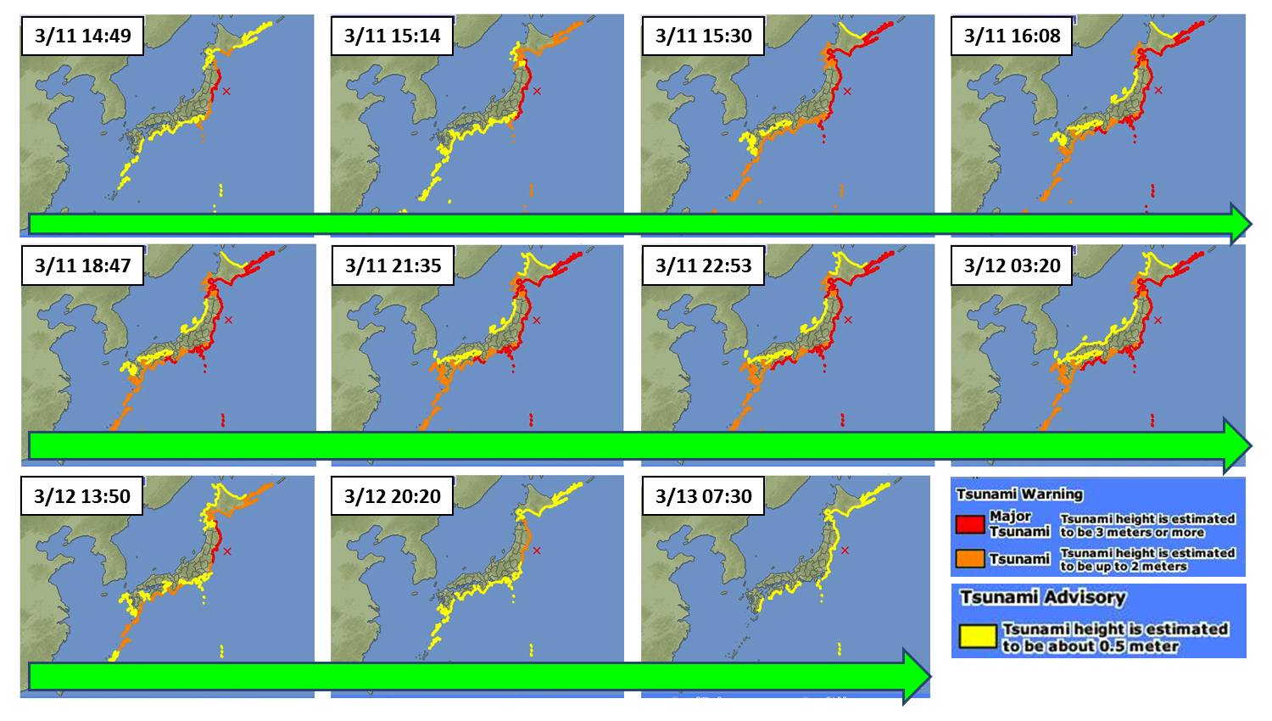
Figure 6. The complete sequence of tsunami early warning (in local time; UTC+9) issued by the JMA during the 2011 East Japan tsunami
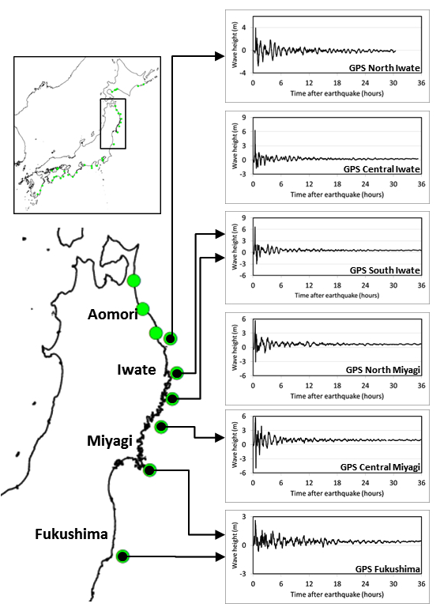
Figure 7. The observed tsunami data from RTK-GPS located in off the Tohoku coast during the 2011 East Japan earthquake-tsunami
The observed tsunami offshore indicated that the energy lasted up to 6 hours with a peak during the first two hours. In the coastal area in the north and southern Japan, the tsunami was observed 1 to 36 hours after the earthquake. These observations are consistent with the decision made by the JMA to cancel the warning after 42 hours. Thus, it can be seen that the warning was cancelled after all of the supporting data indicated that the tsunami hazard had been diminished.
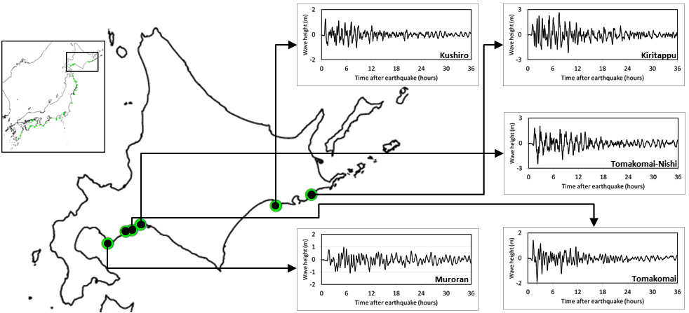
Figure 8. The observed tsunami data from tide gauges located in Hokkaido during the 2011 East Japan earthquake-tsunami
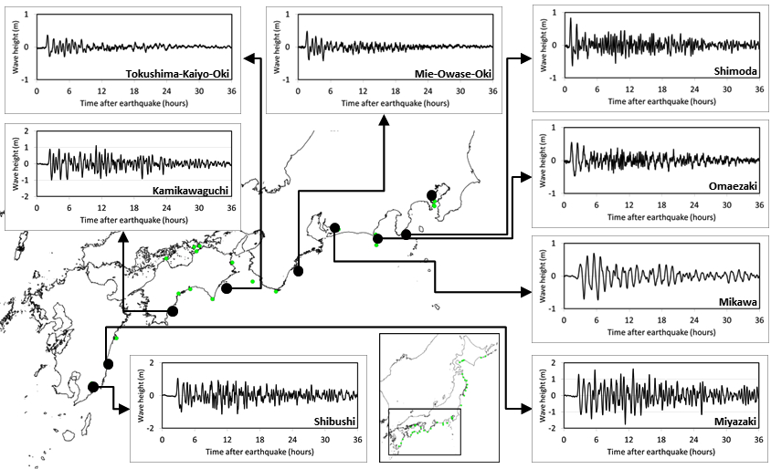
Figure 9. The observed tsunami data from ride gauges located in southern Japan during the 2011 East Japan earthquake-tsunami

2.2.2 Far-field case in Papua, Indonesia
One man died during the 2011 Japan tsunami in Jayapura, Indonesia. At this time, similar to the condition during the 2010 Mentawai tsunami, there was no problem on warning issue and dissemination time. Tsunami warning for the eastern Indonesian region was issued by the NTWC-BMKG two hours after the earthquake in Japan and was updated twice before being cancelled 5 hours later (Fig. 10).
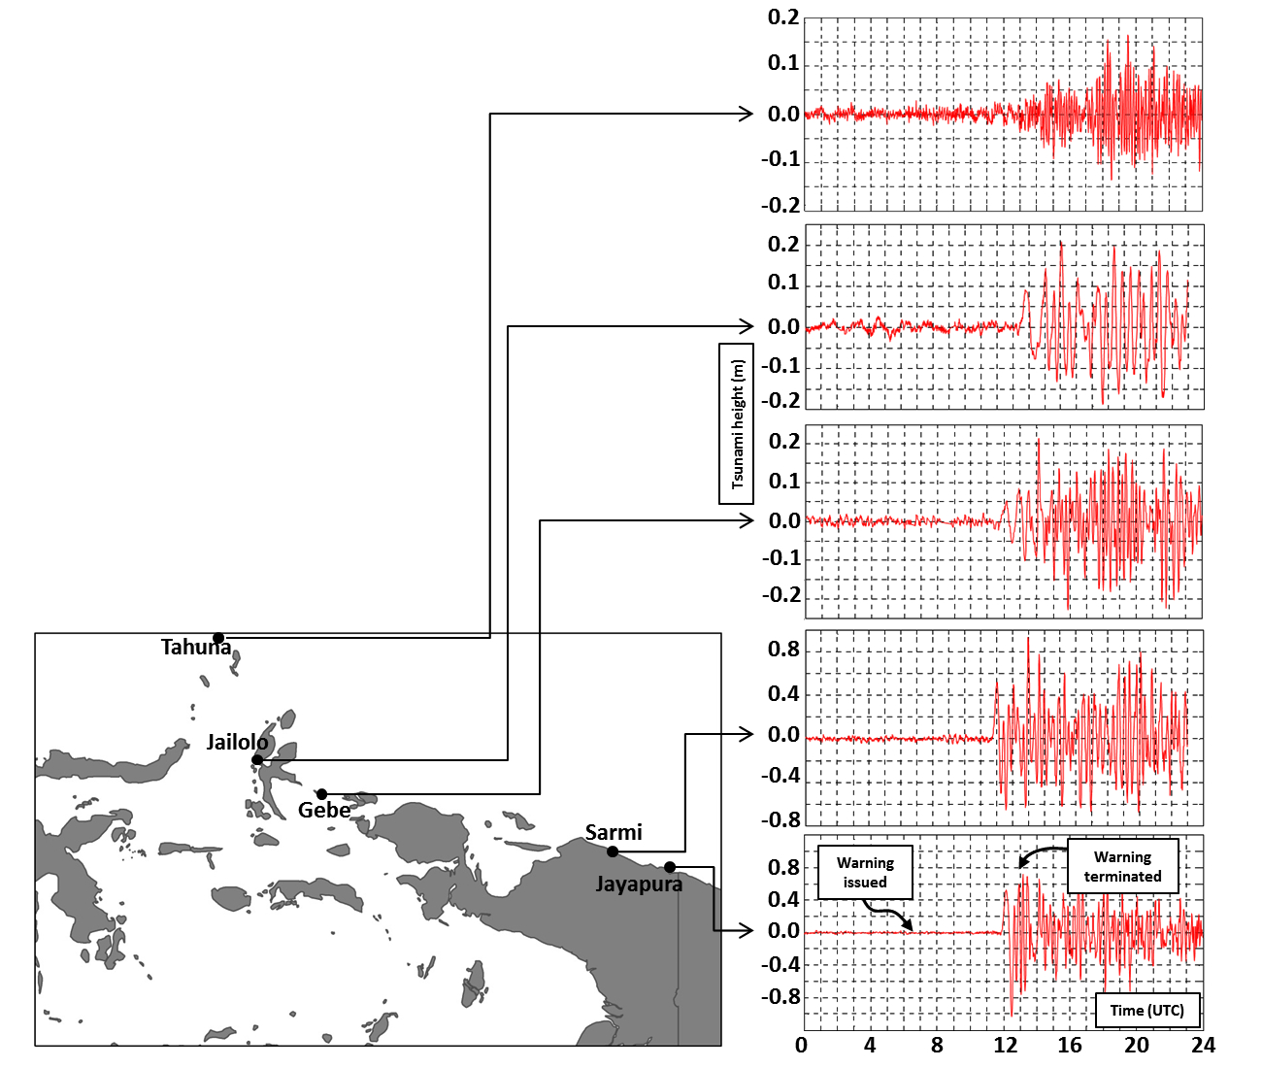
Figure 10. The observed tsunami data from tide gauges located in Papua region, Indonesia (Khafid and Handayani, 2011)
The warning sequence released by the NTWC is translated and summarized as follows,
1st warning, 16:34 local time (UTC+9):
Tsunami warning: Papua, North Moluccas, North Sulawesi, estimated arrival time 20:00 local time, due to a M 8.8 earthquake in Japan, 2011 March 11, 12:46:22 West Indonesian time (UTC+7), Location: 38.49N 142.79E, Depth: 44 km (Geophysics, Climatology and Meteorology Agency, BMKG).

1st update, 20:09 local time (UTC+9):
Update: A 0.2 m tsunami has been detected on Yap Island. It is estimated to arrive in North Sulawesi, Molucca, and Papua at 20:35 local time (UTC+9), Geophysics, Climatology and Meteorology Agency (BMKG).

2nd update, 21:33 local time (UTC+9):
Update: A 0.1 m tsunami has been observed in Bitung (North Sulawesi) at 20:50 local time and in Halmahera (Molucca) at 21:05 local time (UTC+9), Geophysics, Climatology and Meteorology Agency (BMKG).

3rd update (warning cancellation), 21:55 local time (UTC+9):
The tsunami warning issued due to the M 8.9 earthquake in Japan has been terminated for the entire coast of Indonesia.
By referring to the observed tsunami from the available tide gauges, the warning cancellation time became controversial. A tide gauge in Jayapura –the city where there is one tsunami victim, clearly shows that the tsunami was still ongoing when the warning was terminated. This is a different situation compared to the condition during the 2010 Mentawai tsunami where there were no tidal gauges nearby to confirm the tsunami arrival. In Papua, tide gauges were available and recorded the tsunami well. Upon the termination of the warning, locals returned to the lowland area and eventually one of them was swept away by the tsunami one hour after the warning termination.
There was no official explanation for that unnecessary warning termination. We assumed that underestimation of tsunami height was one of the reasons for the cancellation. The tsunami waves were observed to be less than one meter at all tide gauges (Fig. 10), similarly to the ones observed during the 2010 Mentawai tsunami. By having only less than one meter peak-to-trough tsunami in the surrounding tide gauges, one can assume that a tsunami may not affect the community severely. However, this kind of assumption can eventually be wrong. A post-tsunami survey that was conducted one week after the tsunami surprisingly found that the tsunami damaged around 40 houses, a road, bridge and a number of fishery boats (Diposaptono et al. 2013).
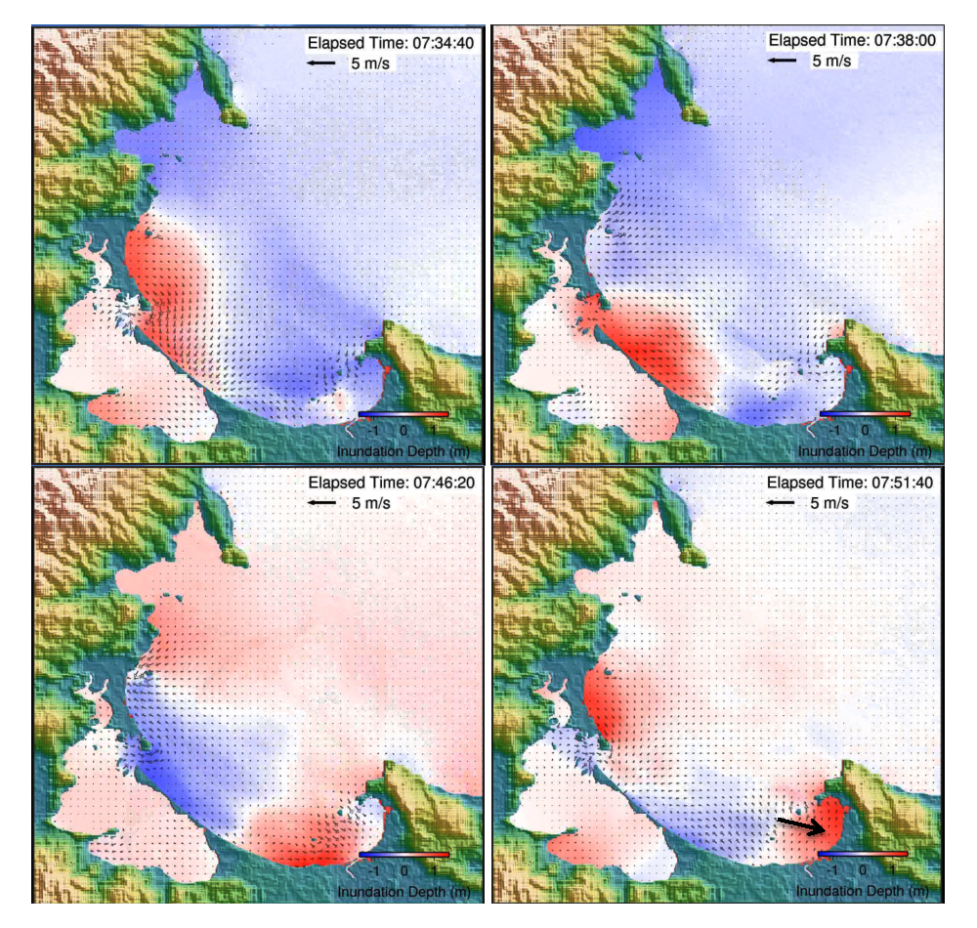
Figure 11. The snapshot of the tsunami wave height and currents in the Papua Bay. Big arrow pointed location of the tsunami victim
In the case of a far-field tsunami, there is more time available before a tsunami can hit a specific area on the other side of the ocean. Thus, we are again testing the use of numerical simulation to support decision-making on warning cancellation. The damages observed through the field survey cannot be explained by only 80 cm tsunami recorded in the nearest tide gauge. Local scale numerical simulations are needed to explain the damages. We reproduce the recent findings by Diposaptono et al. (2013) in a similar personal computer used to run the 2010 Mentawai tsunami. It takes only four hours calculation time to complete the simulation for 10 hours tsunami propagation. It means the computational time is still faster than the arrival time of the 2011 East Japan tsunami in the Indonesian region.
The numerical results indicate that the tsunami may have a dynamic characteristic depending on the shape of coastal morphology. In the case of Papua, the tsunami was amplified by the oscillation inside the pocket beach and caused the tsunami height in some areas to increase up to 4 m. Figure 11 gives the snapshot of tsunami propagation in Papua Bay with the possible location of the victim according to eyewitness accounts.

3. Conclusions and ways ahead
Based on the experiences described above, natural hazards may have physical/environmental driven local characteristics. This aspect, in one hand, may not able to be observed by relying only on static measurement devices (if any) in most existing early warning systems. The impossibility to forecast such factor may lead to severe damages including potential loss of life. On the other hand, relying the warning communication to the local authority is risky since there exists a lack of appropriate capacity and knowledge of early warning in particular, and disaster risk reduction in general.
Numerical models may be one of the most feasible solutions to support decision on warning termination based on real time monitoring data. In this article, we showed that the local scale numerical simulation can be very useful to overcome the absence of real time monitoring equipment, inadequate capacity of local authorities or in estimating local dynamics to avoid underestimation of the tsunami hazard. Recent developments of real time numerical models to support the tsunami warning system (Tang et al. 2009; Gusman et al. 2013) show a promising implementation of such concept. The only potential obstacle when applying this concept in developing countries is the availability of detailed topographic data. Thus, a global initiative may be needed to accelerate the availability of such data for developing countries.

References
Basher, R, 2006. Global early warning system for natural hazards: systematic and people-centered. Phil. Trans. R. Soc. A, 364, 2167-2182.
Goto, C. Y. Ogawa, N. Shuto and F. Imamura, 1997. Numerical method of tsunami simulation with the leap-frog scheme. IUGG/IOC Time Project, IOC Manuals and Guides No. 35. UNESCO, Paris, France.
Pariatmono, 2012. The influence of Mentawai tsunami to public policy on tsunami warning in Indonesia. Journal of Disaster Research, Vol. 7, No. 1, 102-106.
Steinmetz, T., U. Raape, S. Tessmann, C. Strobl, M. Friedemann, T. Kukofka, T. Riedlinger, E. Mikusch and S. Dech, 2010. Tsunami early warning and decision support. Nat. Hazards Earth Syst. Sci., 10, 1839-1850.
Koshimura, S., F. Imamura and N. Shuto, 2001. Characteristics of tsunami propagating over oceanic ridges: numerical simulation of the 1996 irian Jaya earthquake tsunami. Nat. hazards, 24, 213-229.
Mojfield, H. O., V. V. Titov, F. I. Gonzales and J. C. Newman, 2001. Tsunami scattering provinces in the Pacific Ocean. Geophys. Res. Lett., Vol. 28, No. 2, 335-338.
Koshimura, S. Y. Hayashi, K. Munemoto and F. Imamura, 2008. Effect of the emperor seamount on trans-oceanic propagation of the 2006 Kuril Island earthquake tsunami. Geophys. Res. Lett., Vol. 35, No. 2, L02611, doi:10.1029/2007GL032129.
Hayashi, Y., S. Koshimura and F. Imamura, 2012. Comparison of decay features of the 2006 and 2007 Kuril Island earthquake tsunamis. Geophys. J. Int., 190, 347-357.
Diposaptono, S., A. Muhari, F. Imamura, S. Koshimura and H. Yanagisawa, 2013. Impacts of the 2011 East Japan tsunami in Papua region, Indonesia: field observation data and numerical analyses. Geophys. J. Int., 194 (3), 1625-1639.
Hayashi,Y., 2011. Present research status and foresight on timely cancelation of tsunami warning, in Proceedings of the IUGG General Assembly, 28 June–7 July, Melbourne, Australia.
Hill, E. M., J. C. Borrero, Z. Huang, Q. Qiu, P. Banarjee, D. H. Natawidjaja, P. Elosegui, H. M. Fritz, B. W. Suwargadhi, I. R. Pranantyo, L. Li, K. A. Macpherson, V. Skanavis, C. E. Synolakis, and K. Sieh, 2012. The 2010 Mw 7.8 Mentawai earthquake: very shallow source of a rare tsunami earthquake determined from tsunami field survey and near-field GPS data. J. Geophys. Res. 117, B06402, doi:10.1029/2012JB009159.
Satake, K., Y. Nishimura, P. S. Putra, A. R. Gusman, H. Sunendar, Y. Fujii, Y. Tanioka, H. Latief and E. Yulianto, 2013. Tsunami source of the 2010 Mentawai, Indonesia earthquake inferred from tsunami field survey and waveform modeling. Pure. Appl. Geophys. 170, 1567-1582.
Lay, T., C.J. Ammon, H. Kanamori, Y. Yamazaki, K. F. Cheung and A. R. Hutko, 2011. The 25 October Mentawai tsunami earthquake (Mw 7.8) and the tsunami hazard presented by shallow megathrust ruptures. Geophys. Res. Lett., Vol. 38, L06302, doi:10.1029/2010GL046552.
Muhari, A., F. Imamura, S. Diposaptono. 2011. Tsunami Mentawai 2010: Analisis kejadian dan proyeksi kesiapsiagaan di masa depan (The 2010 Mentawai tsunami: analyses and prediction local’s preparedness in the future). Inovasi Online, Vol. 81 (XXII), 5-13. (In Indonesian).
Mikami, T., T. Shibayama, M. Esteban, K. Ohira, J. Sasaki, T. Suzuki, H. Achiari, T. Widodo, 2013. Tsunami vulnerability evaluation in the Mentawai island based on the field survey of the 2010 tsunami. Nat. Hazards, DOI 10.1007/s11069-013-0936-z.
Spahn, H., M. Hoppe, H. D. Vidiarina and B. Usdianto, 2010. Experience from three years of local capacity development for tsunami early warning in Indonesia: challenges, lessons and way ahead. Nat. Hazards Earth Syst. Sci., 10, 1411-1429.
Stunz, G., J. Post, K. Zosseder, S. wegscheider, M. Muck, T. Riedliger, H. Mehl, S. Dech, J. Birkmann, N. Gebert, H. Harjono, H. Z. Anwar, Sumaryono, R. M. Khomarudin and A. Muhari, 2011. Tsunami risk assessment in Indonesia. Nat. Hazards Earth Syst. Sci., 11, 67-82.
Tanioka, Y., A. R. Gusman, K. Loki and Y. Nakamura, 2013. Real-time tsunami inundatin forecast for a recurrence of 17 century great Hokkaido earthquake. Paper presented in the International Tsunami Symposium (ITS), The IUGG Joint tsunami commission, 25-28 September 2013, Gocek Turkey and Rhodes, Greece.
Borrero, J., Fritz, H. M., Suwargadhi, B., Li, L., Qiang, Q., I. R. Pranantyo, C. E. Synolakis, V. Skanavis, 2010. Field survey of the southern Mentawai islands following the 25 October, 2010 earthquke and tsunami. Mentawai Islands tsunami field survey. Available at http://blog.asrltd.com/storage/mentawai_field_survey.pdf. Last access, January 2014.
Imamura, F., and K. Abe, 2009. History and challenge of tsunami warning system in Japan. Journal of Disaster Research, Vol. 4, No. 4, 267-271.
Kato, T., Y. Terada, M. Kinoshita, H. Kakimoto, H. Isshiki, M. Matsuishi, A. Yokotama and T. Tanno, 2000. Real-time observation of tsunami by RTK-GPS. Earth Planet Space, 52, 841-845.
Ministry of Land, Infrastructures and Transport (MLIT), 2011. Real time Nation Wide Ocean Wave Information Network for Ports and Harbors-NOWPHAS, http://www.mlit.go.jp/kowan/nowphas/index_eng.html10.1093/gji/ggt175.html, last accessed April 2012
Khafid & S. Handayani, 2011. Report of the 2011 Japan tsunami monitoring with the tide gauge stations of Indonesian Geospatial Agency in Papua, Molucca and North Sulawesi, Indonesian Geospatial Agency (BGI), Internal report (in Indonesian).

